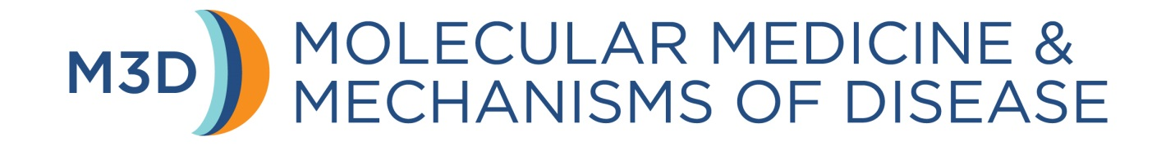
M3D PhD Program
LABORATORY ROTATION EVALUATION

STUDENT:

ROTATION MENTOR:

Quarter, Year:

In the space below indicate whether the student has performed satisfactorily during this quarter’s rotation in your lab. State the subject of the project, the goals, and whether the student completed these goals. Give a brief critique of his/her performance, noting both strengths and areas that could use improvement.

Faculty mentors (or designated lab members or colleagues) are required to attend end-of-quarter rotation presentations and critique student performance. Please provide an evaluation of the student’s presentation below. If you did not attend yourself, name the individual who attended on your behalf.

Rotation mentors are required to meet with the student to discuss the evaluation. Confirm that you have done so by typing your name below:

Name:

Date:

Please return this form via e-mail to the M3D PhD Program Office (M3D@uw.edu).
This form is due no later than the first Friday of the first week of the quarter following the rotation.

